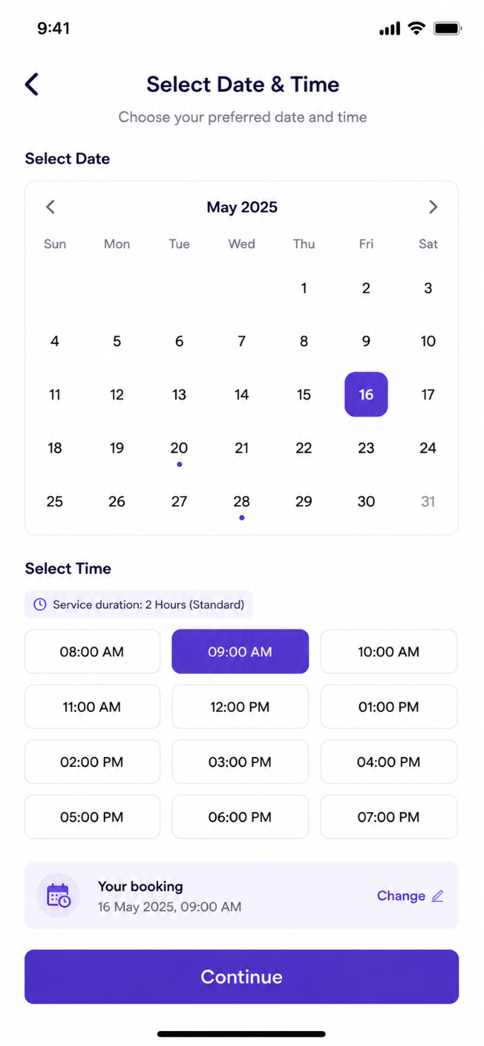
User Story: Select Date & Time Screen
Epic: Service Scheduling & Slot Management
This screen allows customers to select their preferred service date and time slot before confirming the booking.

Business Objective
Allow customers to:
- Choose preferred service date
- Select available time slot
- View service duration
- Prevent overbooking
- Optimize worker allocation
- Improve scheduling accuracy

User Story 1: Select Service Date
As a Customer
I want to choose my preferred service date
So that the professional arrives on my desired day.
Acceptance Criteria
✅ Calendar should display available dates
✅ Customer can select one date
✅ Selected date should be highlighted
✅ Past dates cannot be selected
✅ Booking summary updates automatically

User Story 2: Select Service Time
As a Customer
I want to select an available time slot
So that the service starts at my preferred time.
Acceptance Criteria
✅ Available slots displayed
✅ Only one slot can be selected
✅ Selected slot highlighted
✅ Unavailable slots disabled
✅ Booking summary updates automatically

User Story 3: View Service Duration
As a Customer
I want to know how long the service will take
So that I can plan my schedule.
Acceptance Criteria
✅ Service duration displayed
Example:
- 2 Hours
- 4 Hours
- Full Day
✅ Duration fetched based on selected services

User Story 4: View Booking Summary
As a Customer
I want to review my selected date and time
So that I can verify my booking.
Acceptance Criteria
✅ Booking summary updates instantly
Example:
16 May 2025
09:00 AM
✅ Summary reflects latest changes

User Story 5: Continue Booking
As a Customer
I want to proceed after selecting date and time
So that I can review pricing and payment.
Acceptance Criteria
✅ Date mandatory
✅ Time slot mandatory
✅ Continue enabled only after both selected

Functional Requirements
Calendar Component
Supported Actions
- Select date
- Change month
- View future availability
- Highlight selected date

Date Selection Rules
Rule | Value
Past Date | Not Allowed
Current Date | Allowed
Future Date | Allowed
Max Advance Booking | Configurable
Holiday Blocking | Supported

Slot Management
Example Slots
- 08:00 AM
- 09:00 AM
- 10:00 AM
- 11:00 AM
- 12:00 PM
- 01:00 PM
- 02:00 PM
- 03:00 PM
- 04:00 PM
- 05:00 PM
- 06:00 PM
- 07:00 PM

Slot Status Types
Status | Behaviour
Available | Selectable
Full | Disabled
Holiday | Disabled
Worker Not Available | Disabled
Past Slot | Disabled

Worker Availability Logic
System checks:
Selected Date
↓
Available Workers
↓
Service Skills Match
↓
Distance Validation
↓
Slot Availability
↓
Show Slots

Booking Summary Logic
Example:
Selected Date: 16 May 2025
Selected Time: 09:00 AM

Booking Summary:
16 May 2025, 09:00 AM

Test Cases
TC-01 Screen Load
Scenario
Customer opens Date & Time screen.
Expected Result
Calendar displayed.
Time slots displayed.
Continue button visible.

TC-02 Select Date
Action
Select 16 May.
Expected Result
Date highlighted.
Booking summary updated.

TC-03 Select Time Slot
Action
Select 09:00 AM.
Expected Result
Slot highlighted.
Booking summary updated.

TC-04 Change Date
Action
Select 16 May then 20 May.
Expected Result
Latest selection retained.
Previous selection removed.

TC-05 Change Time Slot
Action
Select 09:00 AM then 11:00 AM.
Expected Result
Only 11:00 AM selected.

TC-06 Continue Without Date
Action
Select time only.
Click Continue.
Expected Result
Error:
"Please select a date."

TC-07 Continue Without Time
Action
Select date only.
Click Continue.
Expected Result
Error:
"Please select a time slot."

TC-08 Continue With Date & Time
Action
Select date and time.
Click Continue.
Expected Result
Navigate to Booking Summary screen.

TC-09 Select Past Date
Action
Try selecting yesterday.
Expected Result
Selection blocked.

TC-10 Fully Booked Slot
Action
Open date with no worker availability.
Expected Result
Slot disabled.
Show:
"Fully Booked"

TC-11 Month Navigation
Action
Click next month.
Expected Result
Next month calendar displayed.

TC-12 Previous Month Navigation
Action
Click previous month.
Expected Result
Cannot navigate to past unavailable months.

TC-13 Refresh Screen
Action
Refresh application.
Expected Result
Selected date/time retained if draft booking exists.

TC-14 Service Duration Display
Action
Open scheduling screen.
Expected Result
Duration displayed correctly.
Example:
"Service Duration: 2 Hours"

Edge Cases
EC-01 Slot Becomes Unavailable
Scenario:
Customer selects 09:00 AM.
Another customer books same slot.
Expected:
System re-validates before confirmation.
Display:
"Selected slot is no longer available."

EC-02 Midnight Booking
Scenario:
Booking near day change.
Expected:
Correct date handling.

EC-03 Worker Cancelled
Scenario:
Assigned worker unavailable.
Expected:
System automatically reassigns worker.

EC-04 Holiday
Scenario:
Public holiday blocked.
Expected:
Date disabled.

EC-05 Same-Day Booking
Scenario:
Current time = 11:30 AM
Expected:
08:00–11:00 slots disabled.
Only future slots shown.

API Requirements
Get Available Dates
GET /availability/dates

Response
{
"availableDates":[
"2025-05-16",
"2025-05-20",
"2025-05-28"
]
}

Get Available Slots
GET /availability/slots?date=2025-05-16

Response
{
"slots":[
{
"time":"09:00 AM",
"available":true
},
{
"time":"10:00 AM",
"available":false
}
]
}

Reserve Slot
POST /booking/reserve-slot

{
"bookingId":"BK123",
"date":"2025-05-16",
"slot":"09:00 AM"
}

Admin Configuration
Admin should be able to configure:
- Working hours
- Slot intervals
- Service duration
- Holidays
- Weekend availability
- Maximum bookings per slot
- Emergency booking rules
- City-wise availability

Analytics Events
Track:
- Date Selected
- Slot Selected
- Month Changed
- Continue Clicked
- Slot Unavailable Error
- Booking Abandoned
- Most Preferred Time Slot
- Most Booked Day

Navigation Flow
Login
↓
Select Services
↓
Choose Booking Type
↓
Select Date & Time
↓
Address Selection
↓
Booking Summary
↓
Payment
↓
Booking Confirmed
Additional Operational Rules
Instant Booking
- Skip this screen if worker assigned automatically.
Scheduled Booking
- Date and time selection mandatory.
Recurring Booking
- User selects first booking date.
- Recurring engine creates future schedules automatically.
SLA Rules
Booking Type | SLA
Instant | 10–15 mins
Scheduled | Selected Slot
Recurring | Auto generated
Custom Request | Manual Review Required

